Contents
Task 1: 2
Website 1 - https://www.apple.com/uk/ 2
Introduction 2
Target Audience 2
Accessibility 3
Construction Features 3
Interactive Features 3
Aesthetics 3
Advantages and disadvantages of audio and video 4
Accessibility 4
Strength and weakness of the website 4
Website 2 - https://news.sky.com/uk 5
Introduction: 5
Explain the intended uses and features of the website 5
Target Audience 5
Construction Features 5
Interactive Features 6
Aesthetics 6
Advantage and disadvantage of video and audio 6
Accessibility 6
Strength and weakness of the website 6
Conclusion 7

Task 1:

Website 1 - https://www.apple.com/uk/

Introduction
Apple is an American multinational company located in Cupertino, California, founded by Steve Jobs, Ronald Wayne and Steve Wozniak. They also a range of products from phones, laptops and iPad.e intended uses and features of the website

Target Audience
The apple audience is aimed at professional people who are going to buy their products, so they include a lot of information such as the GB, size and weight. Some people pay attention to those type of information. The website doesn’t have a colourful colour scheme as the colours on the website are either black or white with pictures of the phones and few videos.

Accessibility
The company apple has a website which you can visit on any device (laptop, computer and mobile phones) which means their website is accessible to everyone to visit and view their products. A good feature of the apple website is that its accessible by people who are colour blind as the website’s colour scheme is black and white this, meaning people with difficulty of seeing colour will be able to access this website.

Construction Features
On the webpage there are a lot of hyperlinks, the heading at the top of the page are hyperlinks which take you to a different page with the same layout. The webpage has a section where it allows the user to input where they were satisfied with the information given or not and you also get a text box to give feedback. The main categories are at the top of the page titled (mac, iPad, iPhone, watch, TV, music, support, search and shopping bag). This means using the website easy when looking for something because it’s in white at the top of the website and it remains at the top of the webpage.

Interactive Features
There’s a registration feature on this website and you can create an apple ID, this feature is made for people who have apple devices, there’s also a section if you have lost forgotten your password. The use of the website is to allow users to see what products they are going to release next and it also gives them the ability to pre-order products. This is a good feature as they would have products before other people. A useful feature of this website is that you are able to buy any products that they sell from the website, this means you if you don’t have an apple store where you live you don’t have to travels fare to obtain their products also you don’t have to wait in long que’s when new products are released. In the website there is a section called “Apple Community” and in this area is where you can ask questions and you can find answers or reply to other people’s questions and you can also read other people’s questions.

Aesthetics
Apples website colour scheme is different to other websites because its black and white text and on some pages white with black text. This is good because people who are colour blind are still able to use the website without any difficulties. The apple website’s layout is different and unique as no other website, as you scroll down the website the pictures and text look like they are moving, as you scroll down the webpage it shows the performance of their devices (picture quality and more). On the website they only use one type of font (Helvetica) however they have different size fonts from large to small and some texts are in bold. The website also includes pictures of their products and new products they are going to release, they also have videos of their products and in the videos, it has the devices specification.

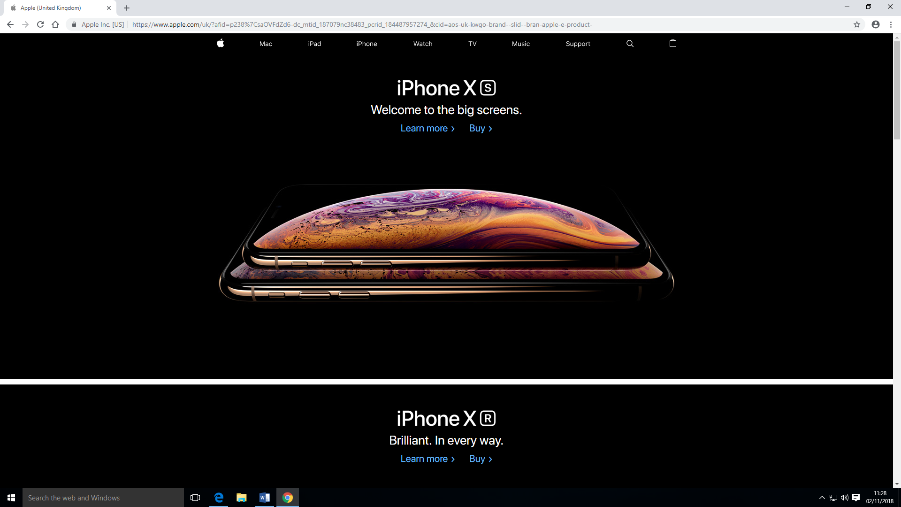

Advantages and disadvantages of audio and video
Advantage of Audio & Videos | Disadvantage of Audio & Videos
An advantage of having videos and pictures of their products is, if people want to pre-order or buy one of their products they would want to know what it looks like | A disadvantage of the audio and videos is that there aren’t a lot of videos on the website
Another advantage of having videos on your website is it lets the users know what their products include is, so the users know what the product looks like, it gives customers ideas of what to expect

Accessibility
This website can be used by people who can colour blindness because they main colour on the website is black and black is an uncommon colour for colour blindness. The black background with white text makes the writing stand out. However, if you are visually impaired there is no way for you to access the website. The website doesn’t include text readers meaning you have to read each bit on information’s which can be quite boring for people who don’t prefer reading. There are images on this website images of the products that are being sold by the company.

Strength and weakness of the website
Strengths of the apple website | Weakness of the apple website
You can buy products online without having to go wait in long que’s | You won’t know how products will look like if you buy it online
There aren’t hyperlinks, so users won’t get lost because hyperlinks bring you onto new webpages | Videos and audio are accessible to anyone as they would have access to the webpage.
It’s easy to navigate with clear titles at the top of the website
The website includes a forum and users can ask questions and their questions can be answered by other users.

Website 2 - https://news.sky.com/uk

Introduction:
Sky news is a news network from Britain, founded by Rupert Murdoch. Sky news isn’t just about political news but also sports.

Explain the intended uses and features of the website

Target Audience
The target audience for Sky News is for professional people as there aren’t a lot of bright colours and there is quite lengthy text. The text on this website is sophisticated meaning young people will get bored from reading this website. They also include videos on the website of things that have been on the news.

Construction Features
On the Sky news website there are hyperlinks, a hyperlink that I came across is to a petitioning website, where you can sign to petitions. An advantage the template of this website is quite simple as all the main headings are located at the top of the website and as you scroll down the website there’s pictures with text on them. On the Sky news website there is a place where you can input things, that is the search bar. There are quite a lot of hot spots on the Sky news website, they have a little text next to them explaining the image and when you click on the image it brings you to a new webpage with more information.

Interactive Features
The Sky news website doesn’t have a registration form as it is only for checking the news also you can get apps which you can download onto your phone and you will get notifications onto your phone. Sky news doesn’t have a forum as there will be no need for the audience’s opinion as the information they are giving on their page is like on any other news website.

Aesthetics
On this website they don’t a range of colours which makes the website appealing for adults, the colours on this website are white and red only have two colours on the website means professional people can use this website as it is not targeted at kids. The layout of the website is simple and constant on every link you click which is with the main heading at the top of the website which is (Home, UK, World, Politics, US, Ocean Rescue, Science & Tech, Business and Ents & Arts) and under each heading there is information. All the text on this webpage is the same font however the sizes are different, and some texts have bold text or large text. Audio and videos are included on the website. The website has videos with titles and you can click onto the video you want it will take you to another page with the video on top and more video’s underneath.

Advantage and disadvantage of video and audio
Advantage of Audio & Videos | Disadvantage of Audio & Videos
Not everyone has interests in reading and they might prefer to watch videos. | Can’t be used by people with hearing difficulties
Some people understand better if they are watching something. | You need good internet connection to use this feature and not a lot of people have this
 | Can’t be used by blind people

Accessibility
This website can be used by people who have colour blindness because the main colour on the website in white. This website does not have any text readers how meaning you would have to read each bit of text. The website also includes images along with some text explaining the picture.

Strength and weakness of the website
Strengths of sky news website | Weakness of sky news website
It has hyperlinks meaning you can retrieve information other websites | It can be quite difficult navigating back to the original website you were on, once you’ve hyperlinked.
The website includes video and audio meaning you aren’t reading all the time | This website does not include a forum where uses can input their own input

Conclusion
After looking at both websites, https://news.sky.com/uk and https://www.apple.com/uk/. I have come to the conclusion that both websites are really good and is suitable for people who have colour blidness as the colours that apple use is black with white text this would make the text stand out and people with difficult vision would be apple to see the text better. Similarly sky news use white background with black text this would add the same effect as the apple website which is making the text stand out. The thing that I think apple need to improve on is they should add a feature which allows users to zoom in on text however the way the webiste is presented with the moving images as you scroll down the website makes the website more professional. Wheras with the sky news website theres a lot of pictures and advertisement for other websites which can add a messy feel to the website however the layout can mean that navigating through the webiste is easy.

