Table of Contents
Describe the audience and purpose for the design of a graphic product 2
Product 1: 2
Purpose: 2
Audience: 2
Product 2: 2
Purpose 2
Audience: 2
Produce designs for two digital graphic products with different purposes and audiences. One design must be for a vector image and the other must be for a bitmap image 3
Graphic Product 1: 3
Graphic product 2: 3
Produce detailed graphic product designs, including reasons why alternative ideas have been discarded. 4
Justify the final design decisions 4
Prepare assets for the graphic products, demonstrating awareness of purpose, with a list of sources for ready-made assets. 5
Product 1: 5
Asset table 5
Product 2: 6
Asset table 6
Edit assets to create two graphic products that both include text. Test the products for quality, purpose and against the original requirements, making any necessary improvements. 7
Product 1: 7
Product 2: 8
Final Product 9
Product 1: 9
Product 2: 9
Testing the properties of the assets 10
Gather feedback on the quality of the products, and use it to improve the product, demonstrating awareness of audience and purpose. 11
Product 1: 11
Product 2: 12
Feedback form: 12
Refine assets to create two high-quality digital graphic products 13

Describe the audience and purpose for the design of a graphic product

Product 1:
Purpose: The purpose of my graphic product is to inform my target audience (which is people who like phones and technology) that I am releasing products and al lot people are going to be talking about my product because it’s not like any other. Another purpose of this advertisement is to show my target audience that I have released a new product and people should go buy it. The purpose of my product is to be different from other companies, which do rectangular phones, and I decided to make a triangular phone, which people would like because it is different.
Audience: The target audience for my graphic product is for people aged 16+. I have given this age range because the phone I have created will be quite expensive for someone people to afford. People who are aged 18+ normally have jobs. I have chosen this age range because they are the age range that cares a lot about technology.

Product 2:
Purpose: The intended purpose of my second advert is for healthy eating. The advert will be telling people to be healthier and to eat more fruits and vegetables. Whenever you see my advert, it will encourage people to be healthier. This advert will fit the requirements because it will encourage young adults to start eating healthier.
Audience: The target audience for my graphic product is aimed at people who are aged 12+ because they are the age that eat the unhealthiest out of all people. However, there are under 12 and do eat unhealthily. I have not aimed my advert at a specific gender as anyone could eat unhealthily and it is by choice if someone wants to change and eat healthier. If they start eating healthy then it could change other people and people will start becoming healthier.

Produce designs for two digital graphic products with different purposes and audiences. One design must be for a vector image and the other must be for a bitmap image

Graphic Product 1:

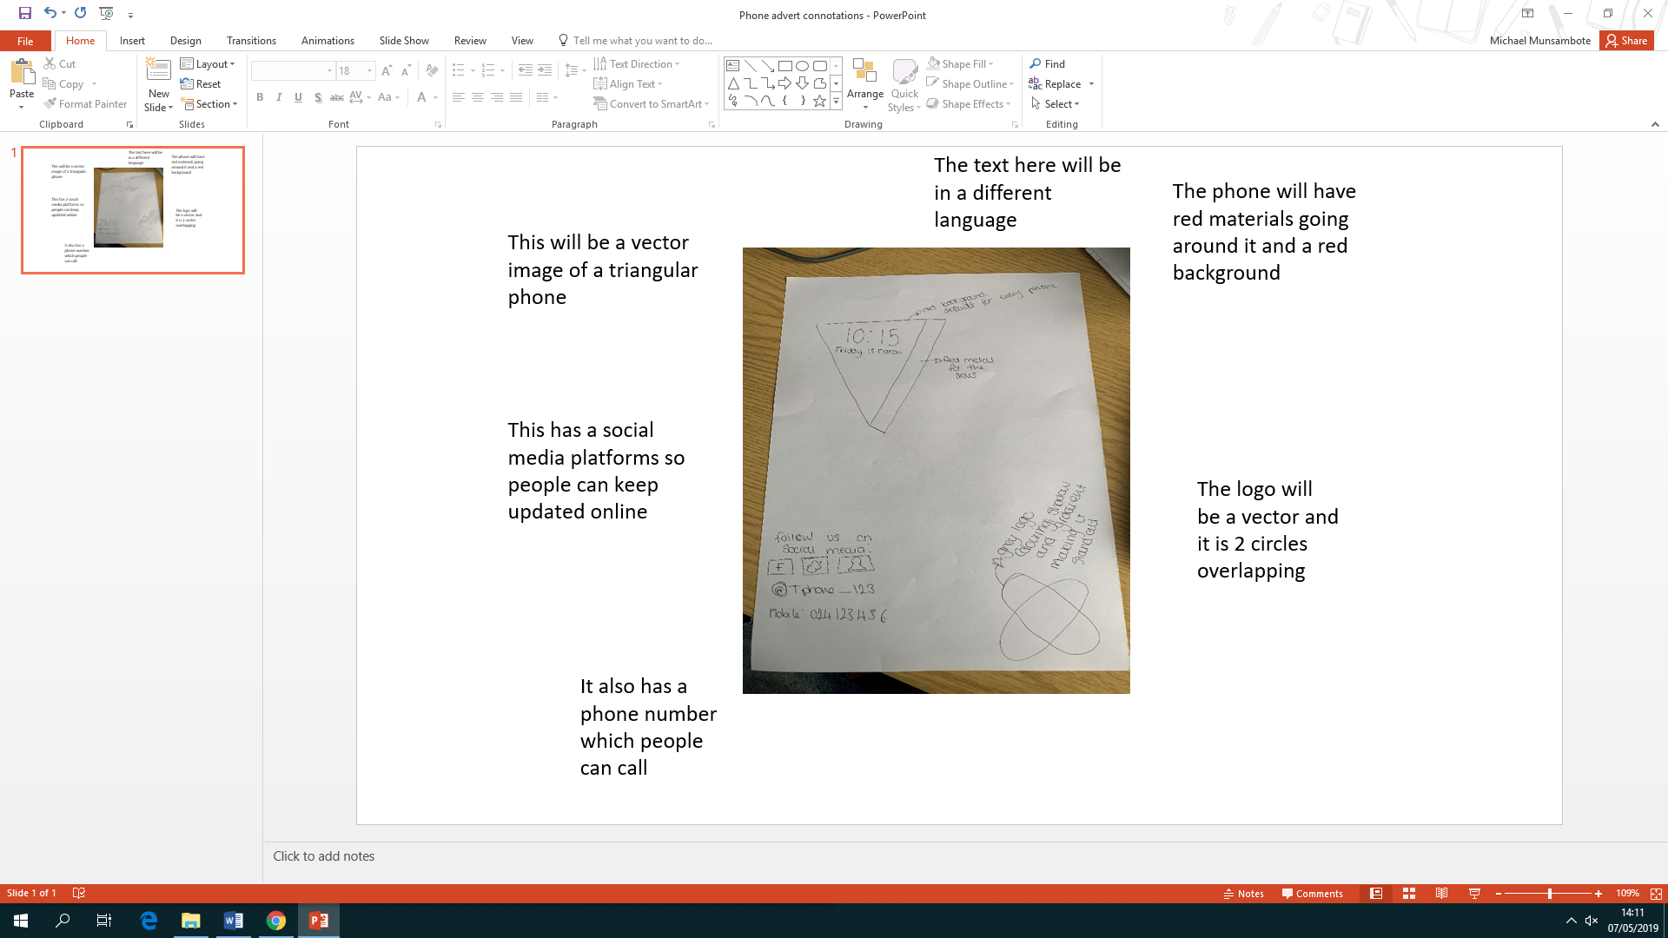

Graphic product 2:

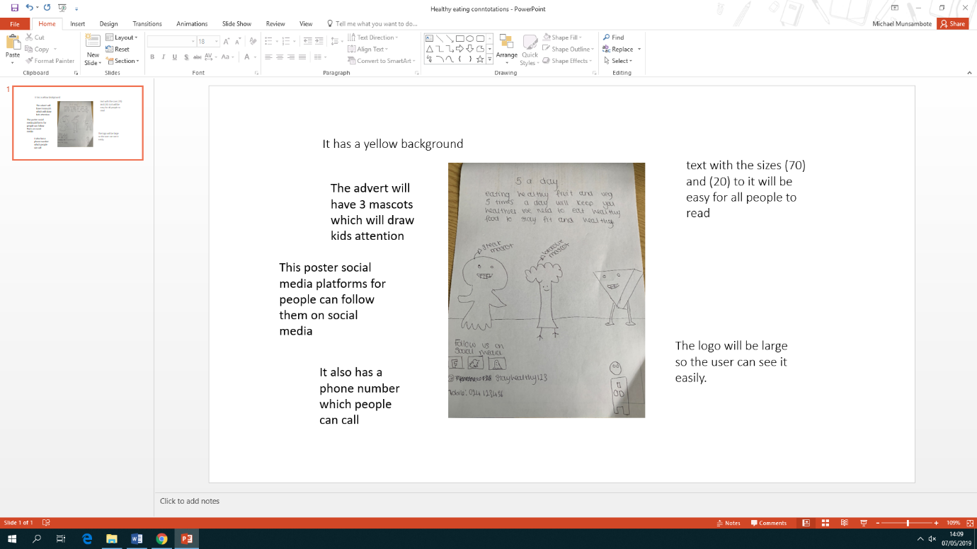

Produce detailed graphic product designs, including reasons why alternative ideas have been discarded.

Below are my designs that I had at the start. The reason why I chose to improve my design is because they were not detailed, and I had not considered what would attract people’s attention. From my first design and my second, I can tell that people are going to enjoy my second product more. One of the main reasons why I did not choose it is because it did not have a way for people to contact me such as a phone number or social media links. Another reason is that the logo was too basic and boring.
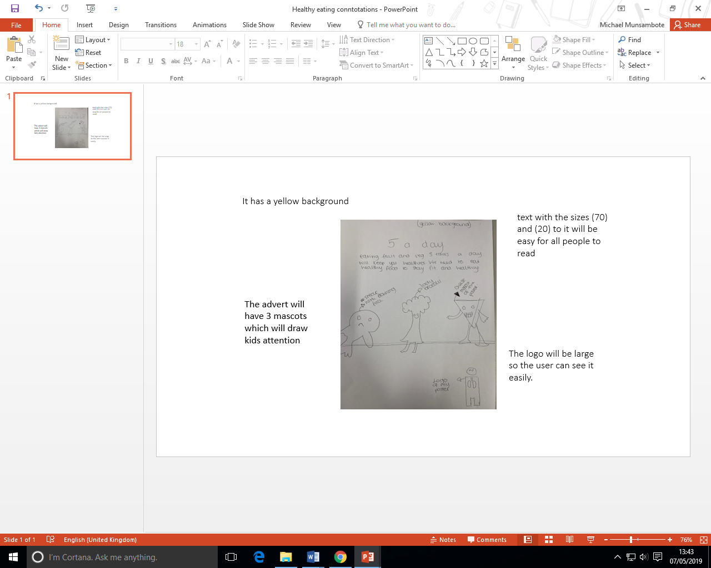
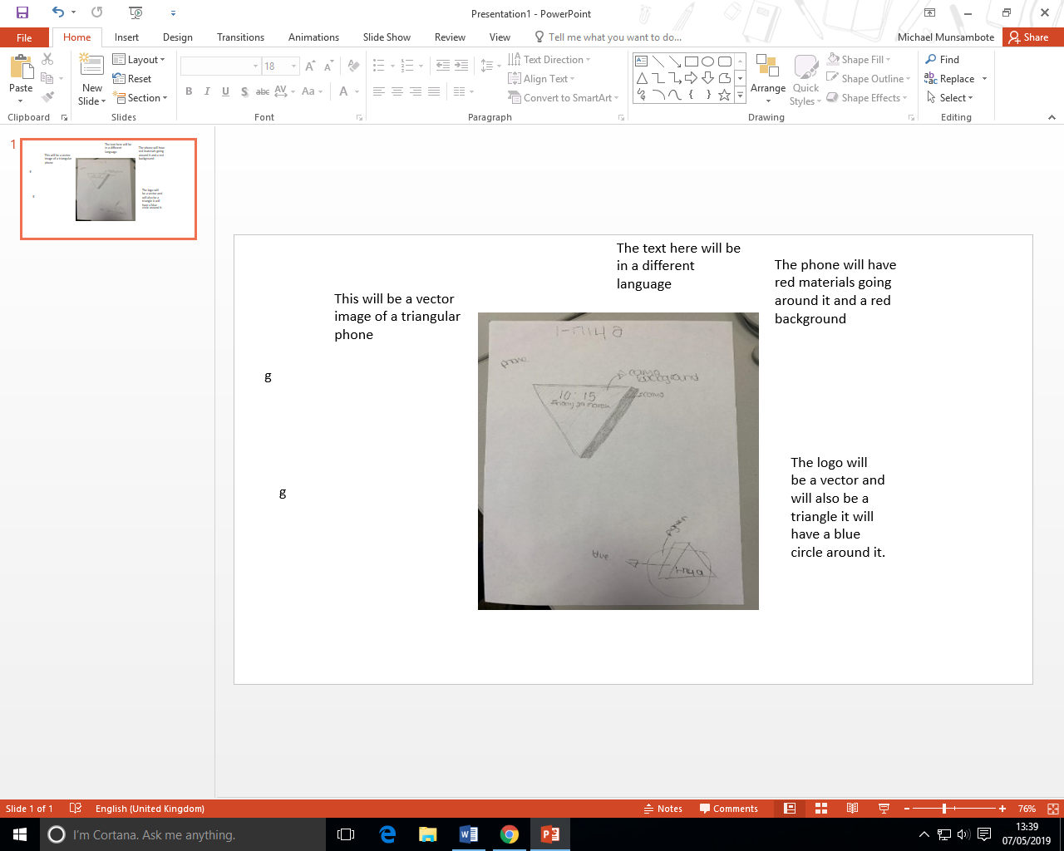

Justify the final design decisions
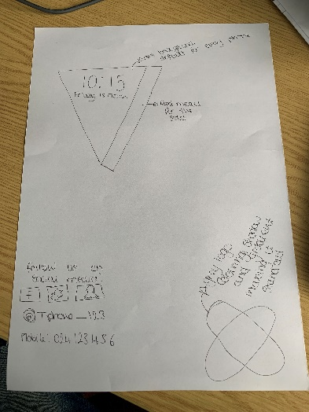
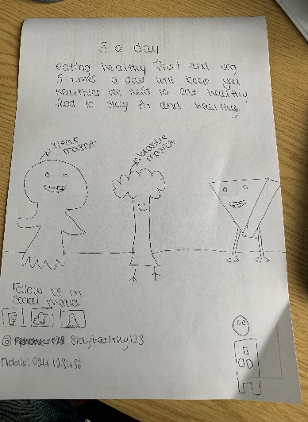

I have chosen this final design because it is more pleasing for the user and the user can access out page on the internet. I have chosen this design because my logo in better and makes for sense for the company unlike my first logo, which was a replica of the phone.

Prepare assets for the graphic products, demonstrating awareness of purpose, with a list of sources for ready-made assets.

Product 1:

Asset table
Number | Description | Type (Photo, Clipart) | Location | Bitmap/vector
1 | The shape of the phone is going to be a triangle, so I made a triangle on adobe. | 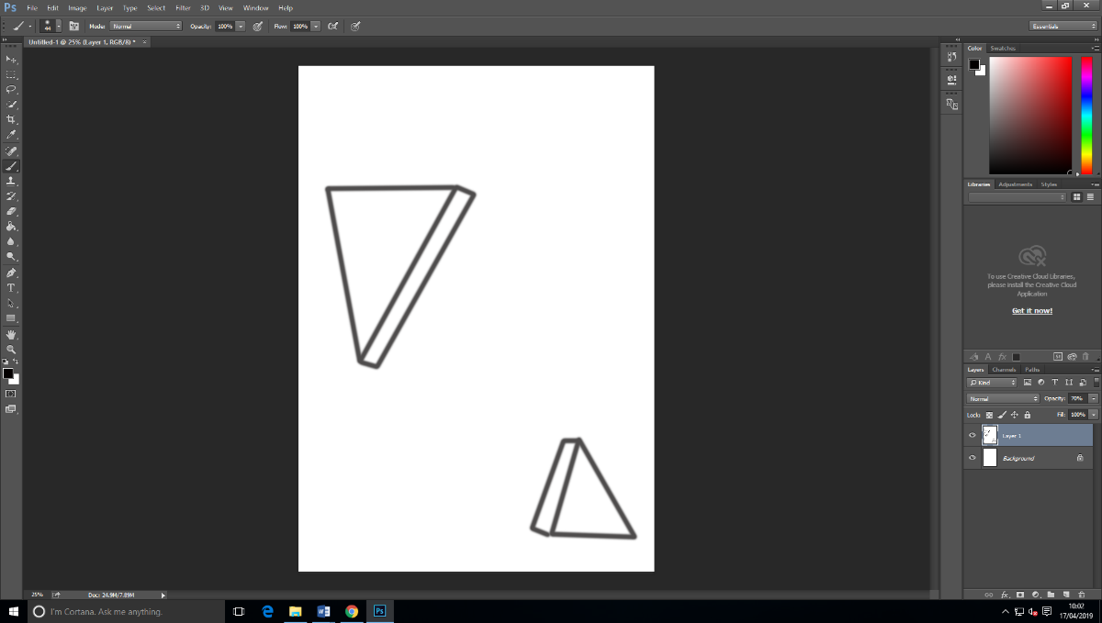  Shape | Adobe Photoshop | Bitmap
2 | My logo is a circle and this I also made on Photoshop. | 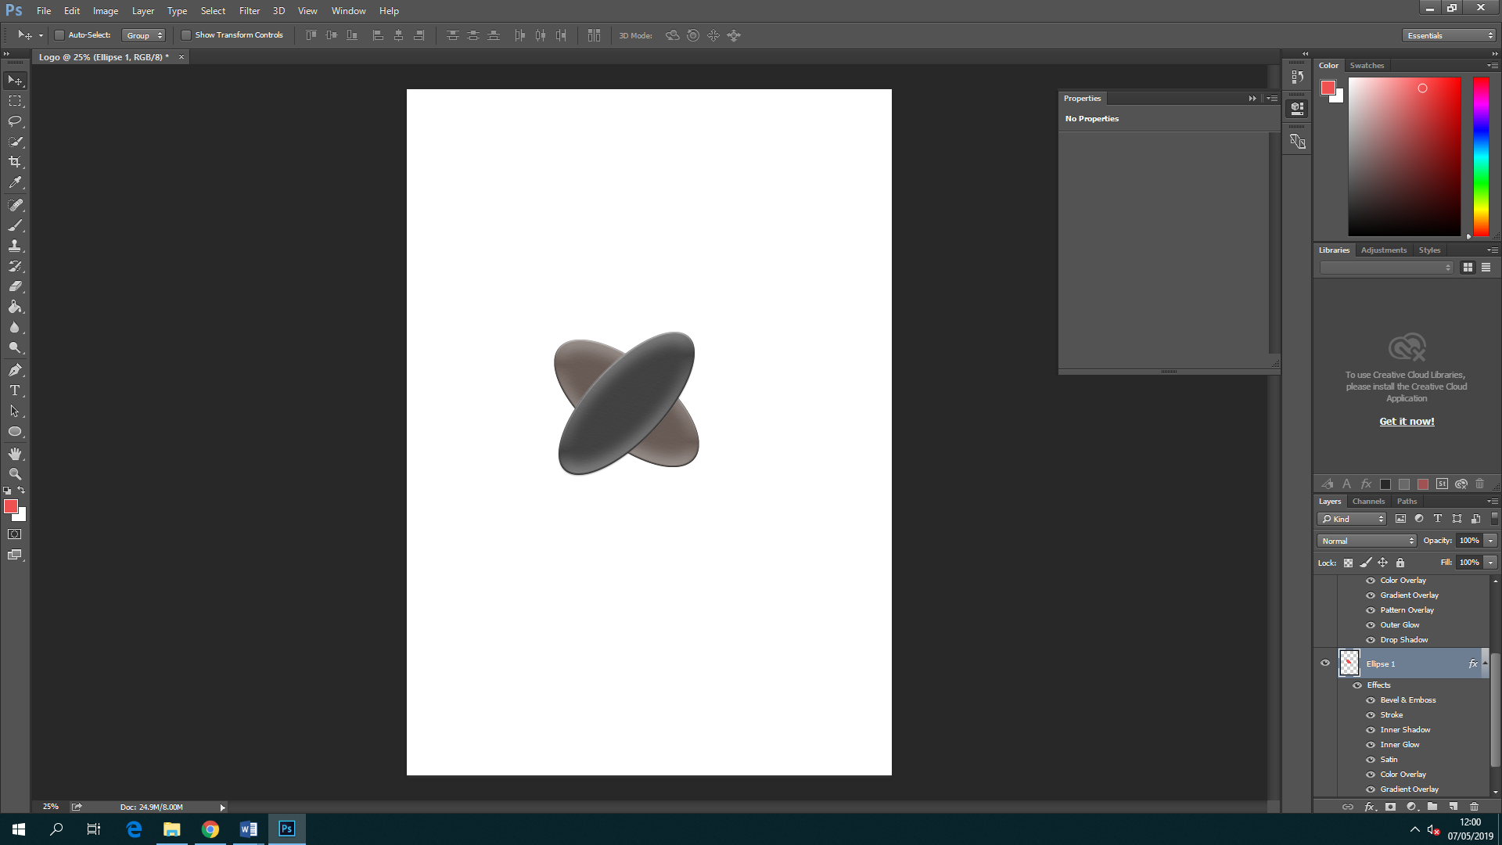  Shape | Adobe Photoshop | Vector
3 | Red metallic frame of the phone |  | Google chrome | Vector
4 | The phone background image |  | Google chrome | Bitmap

Product 2:

Asset table
Number | Description | Type (Photo, Clipart) | Location | Bitmap/vector
1 | The mascot of the vegetable will be fruit, veg, and a piece of meat, which is bad. | Clip art  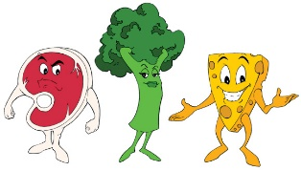 | http://www.mascotdesigngallery.com/tag/healthy/ | Bitmap
2 | Logo. I have chosen this logo because it is a person with a heart, which relates to everyone and makes him or her weary of his or her health. | 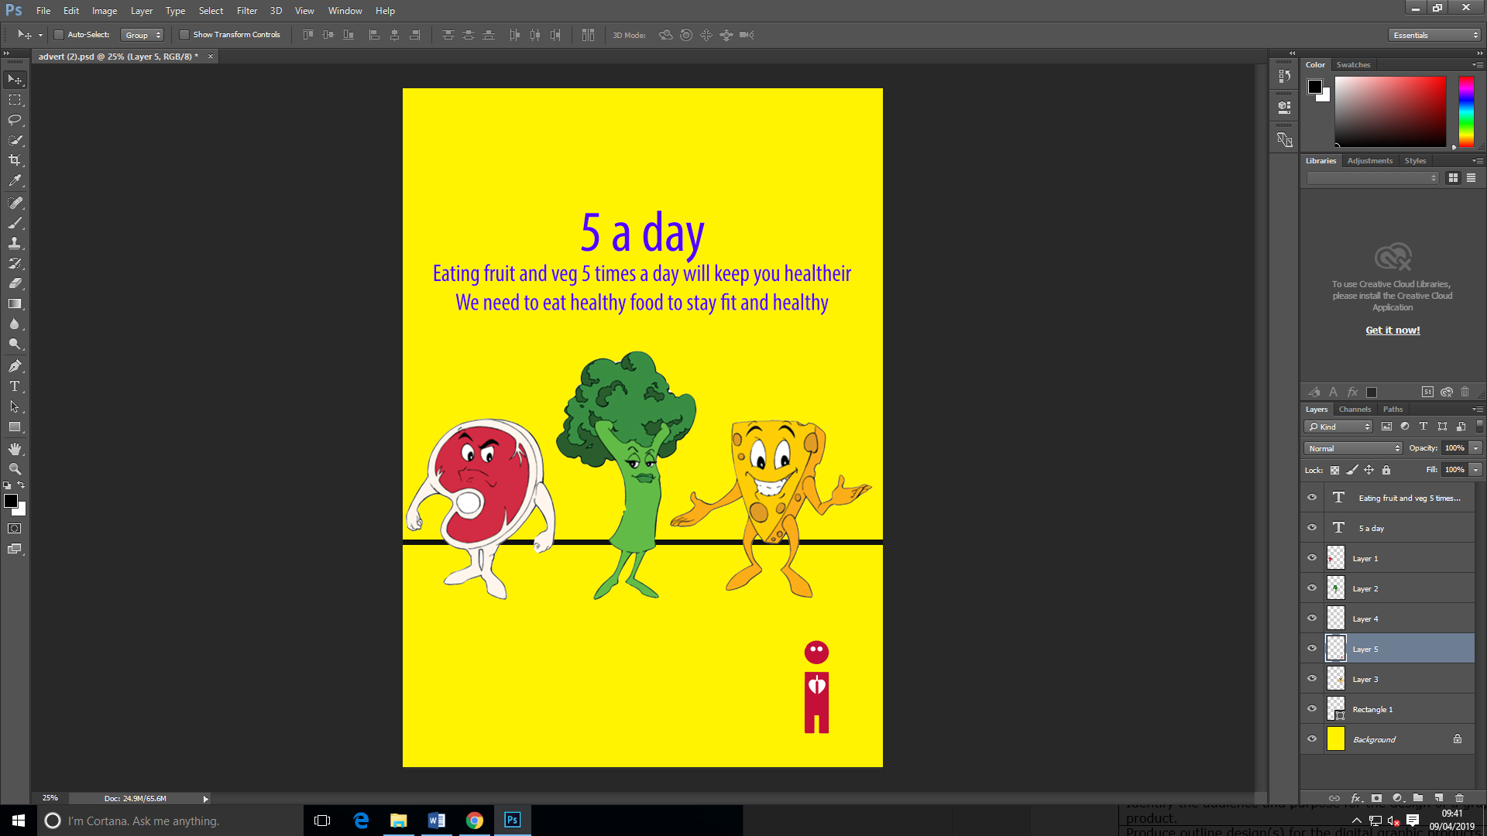 | My folder area | Vector
3 | Yellow background |  | My folder area | Bitmap

Edit assets to create two graphic products that both include text. Test the products for quality, purpose and against the original requirements, making any necessary improvements.

Product 1:
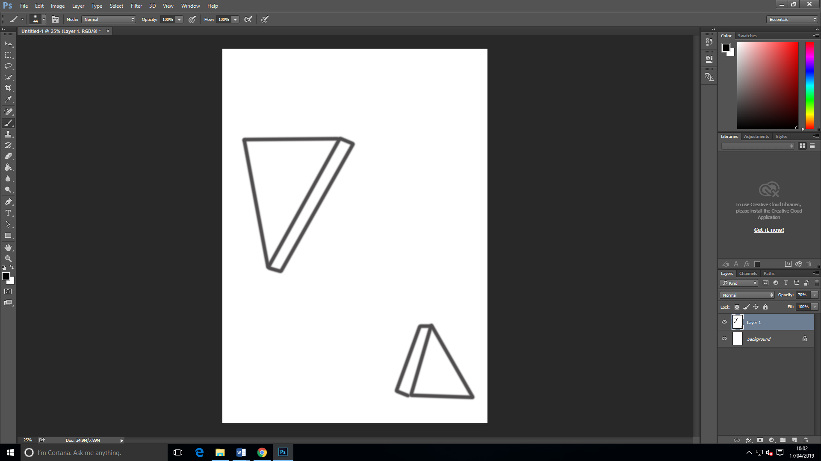

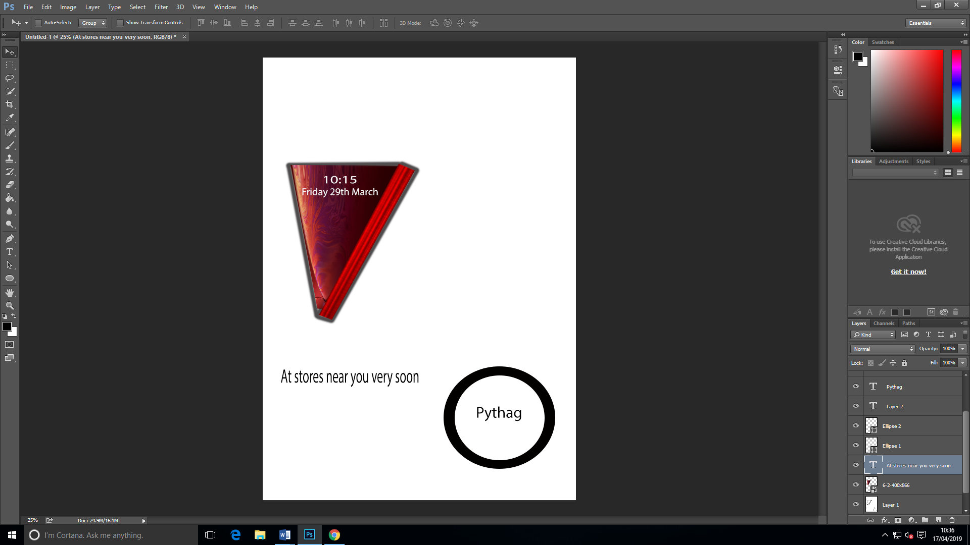

Product 2:
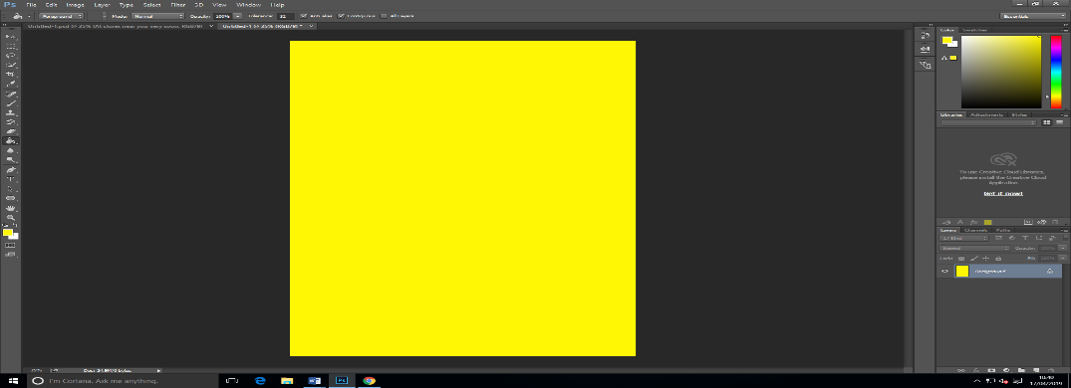

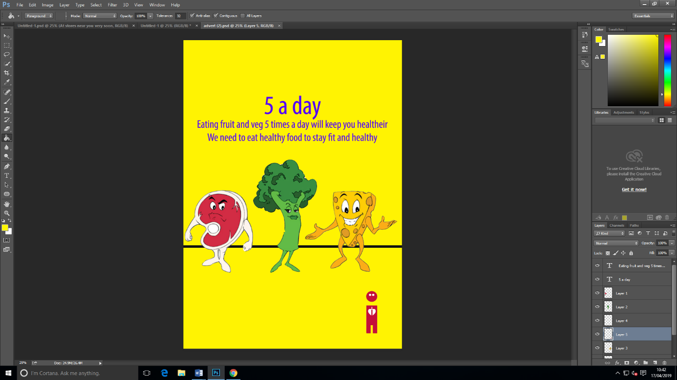

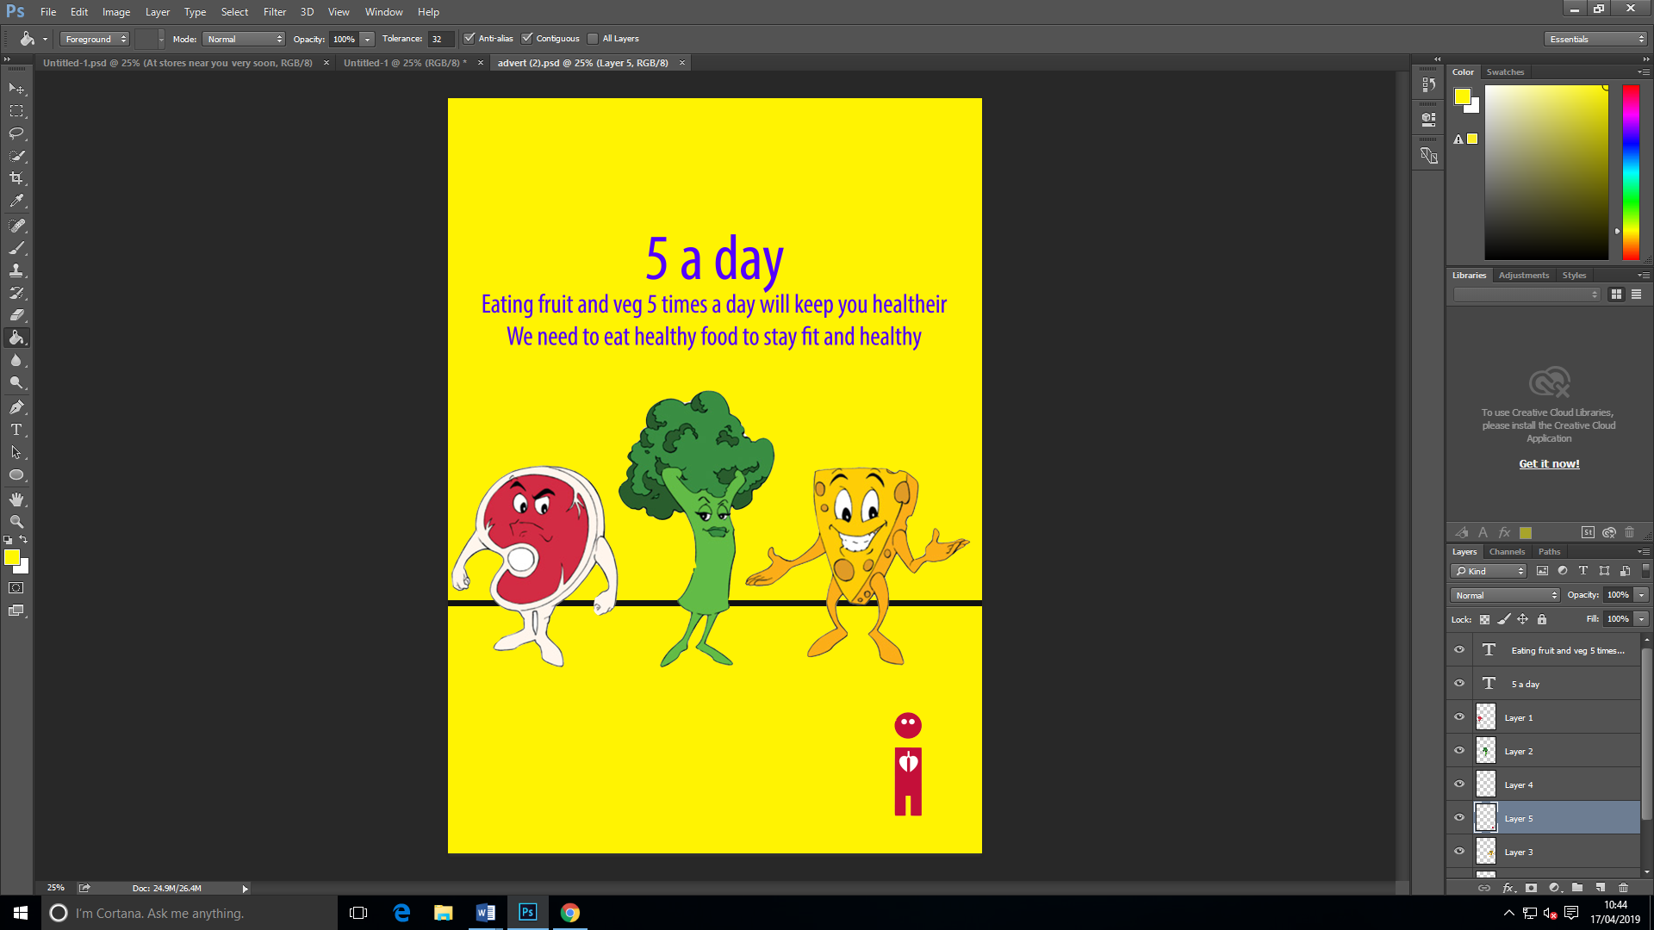
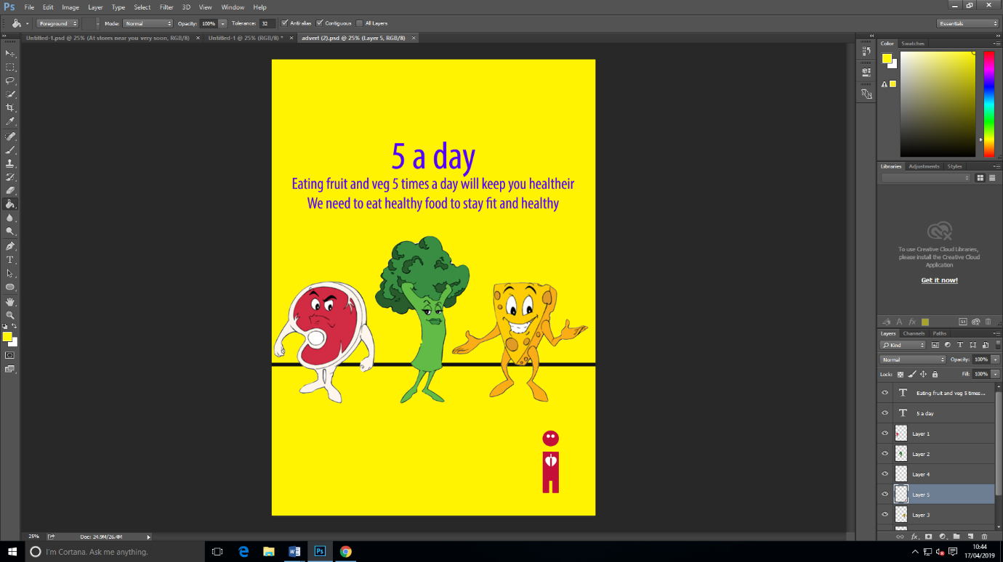

Final Product

Product 1:
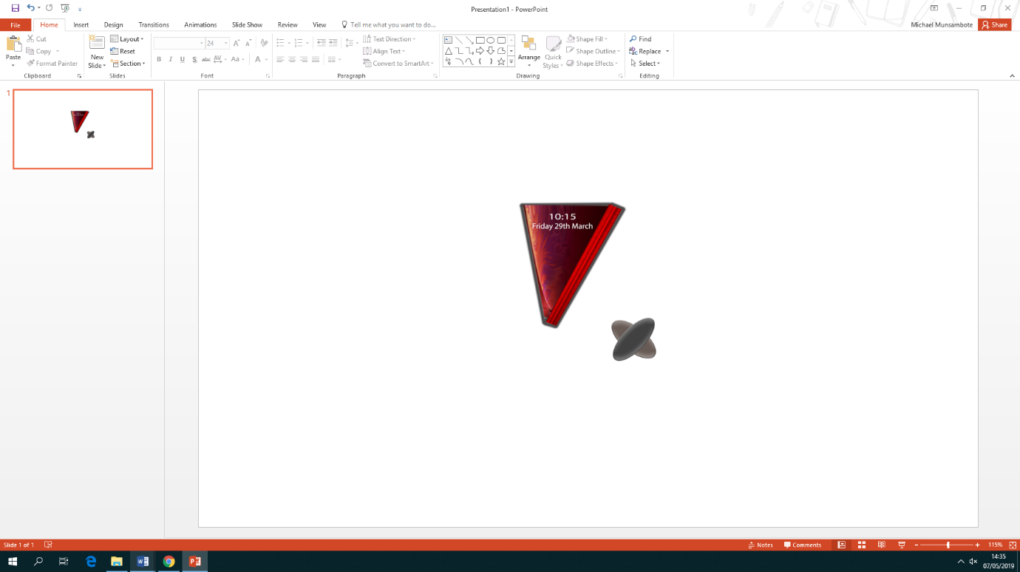

Product 2:
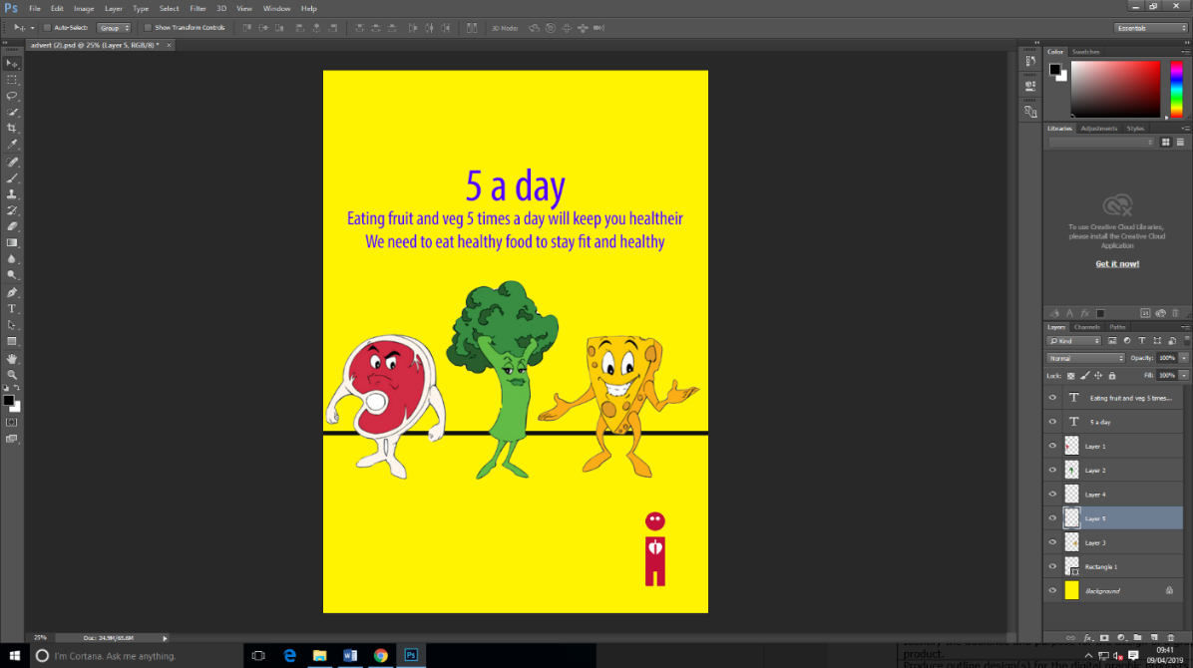

Testing the properties of the assets
What will be tested | Comments
Will the pictures remain clear? | Product 1  Yes, as the pictures are small which does not take up many pixels.  Product 2  Yes, as the pictures have high resolution and small pixels which will be good for the client’s system
Will it be good enough when printed out? | Product 1  Yes, as the assets have high resolution, which will not be affected.  Product 2  The same applies for product two.
Is everything in line and no spelling mistakes | Product 1  Yes everything is in line and up to standard.  Product 2  The same applies for product two.

Gather feedback on the quality of the products, and use it to improve the product, demonstrating awareness of audience and purpose.

Product 1:

Name of graphic: | Advert
Name of reviewer: | Humza Ahmed
Purpose of graphic | To get people to eat healthier
Target Audience | Anyone above the age of 16:
No. | Question | Comments
1 | Is the graphic of suitable size and proportion bearing in mind its purpose? | Yes
2 | Have a suitable range of editing techniques have been used? | Yes, there are images and text used in the advert.
3 | Do you think it will appeal to its target audience | Yes, I think the advert will appeal to the target audience because 16 years olds really like phones and technology.
4 | Is the graphic of acceptable quality? | Yes, all the images are clear and there aren’t any blurry images
5 | What do you think the strengths of this graphic are? | I think the strengths are how different the image is which will appeal to people.
6 | What do you think the weaknesses of this graphic are? | I think the weakness of the poster is that there isn’t any contact information or any social media information
7 | Overall do you think the graphic is fit for its intended purpose | Yes, I think that it will get people to look at it and want to know when the phone will come and make people want to buy it.
8 | Extra Comments? | I think that you could try adding social media links, a website link and a phone number, which people could call.
Thank you for your time!

Product 2:
Name of graphic: | poster
Name of reviewer: | Mark Davis
Purpose of graphic | To get people to eat healthier
Target Audience | Anyone above the age of 12:
No. | Question | Comments
1 | Do you think the advert would attract people’s attention? | Yes, I think that if I saw this poster on the street I would stop, look at it, and consider it.
2 | Have a suitable range of editing techniques have been used? | No, I think there would have been a bit more editing techniques to make the poster interesting.
4 | Is the graphic of acceptable quality? | Yes, I think that the quality of the poster is acceptable because there are not any blurry images and the text legible.
5 | What do you think the strengths of this graphic are? | I think the strength of the poster is the colourful pictures and background that has been used which would attract people’s attention.
6 | What do you think the weaknesses of this graphic are? | I think the weakness of the poster is that there isn’t any contact information or any social media information
7 | Overall do you think the graphic is fit for its intended purpose | Yes, I think that the poster is fit for its intended purpose, which is to get people to start eating healthier.
8 | Do you think it will appeal to its target audience | Yes, I think that the poster will appeal to its audience because 12 years olds would like the bright colours and it would catch their attention.
9 | Extra Comments | I think that you could try adding social media links, a website link and a phone number, which people could call.
Thank you for your time!

Feedback form:

Category | 1 | 2 | 3 | 4
Does it meet the purpose |  |  |  | ✔
Suitable for the target audience |  |  | ✔
Use of colours |  |  |  | ✔
Readable text |  |  | ✔
Appropriate image |  |  | ✔
Fits the intended purpose |  |  |  | ✔
Quality of images |  |  | ✔

Refine assets to create two high-quality digital graphic products

Product 1:
The improvements I made to this product was I added social media links. I made this improvement because I wanted my clients to be able to follow me online so see updates about the phone.
Before: After:
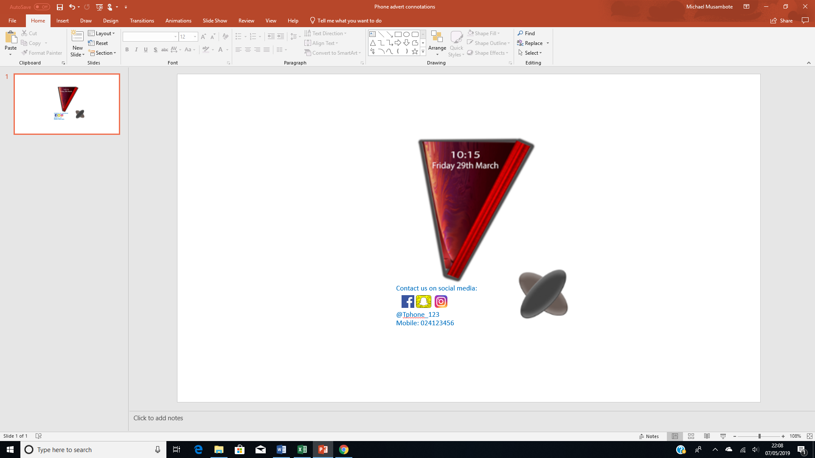

Product 2:
The improvements I made to this product is that I added social media links. Added this because people might want to know more about the course and what our aim is, and they could find it online.

Before: After:
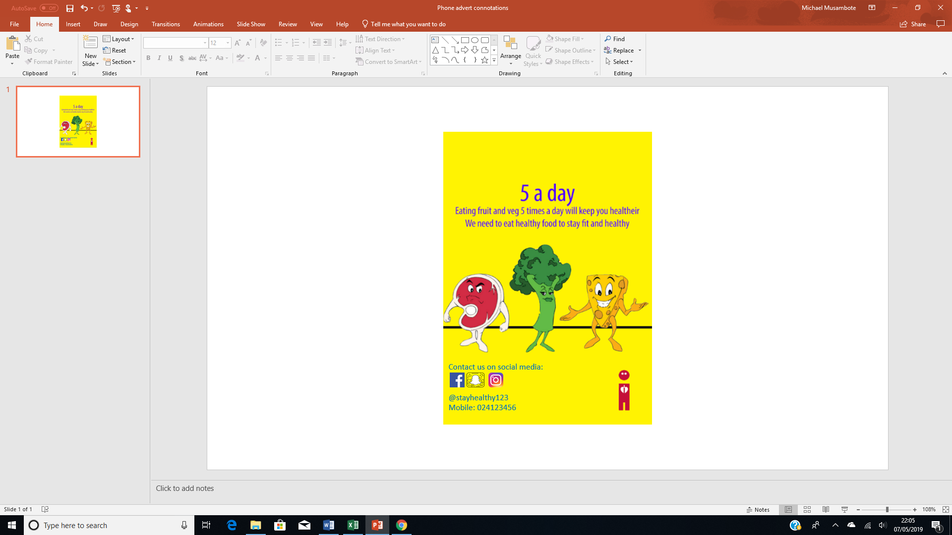

For each of the final graphic products, explain how the final product is suitable for the intended audience and purpose.

Product 1
Purpose: The purpose of my graphic product is to inform my target audience (which is people who like phones and technology) that I am releasing products and al lot people are going to be talking about my product because it’s not like any other. Another purpose of this advertisement is to show my target audience that I have released a new product and people should go buy it. The purpose of my product is to be different from other companies, which do rectangular phones, and I decided to make a triangular phone, which people would like because it is different.
Audience: The target audience for my graphic product is for people aged 16+. I have given this age range because the phone I have created will be quite expensive for someone people to afford. People who are aged 18+ normally have jobs. I have chosen this age range because they are the age range that cares a lot about technology.

Product 2

Purpose: The intended purpose of my second advert is for healthy eating. The advert will be telling people to be healthier and to eat more fruits and vegetables. Whenever you see my advert, it will encourage people to be healthier. This advert will fit the requirements because it will encourage young adults to start eating healthier.

Audience: The target audience for my graphic product is aimed at people who are aged 12+ because they are the age that eat the unhealthiest out of all people. However, there are under 12 and do eat unhealthily. I have not aimed my advert at a specific gender as anyone could eat unhealthily and it is by choice if someone wants to change and eat healthier. If they start eating healthy then it could change other people and people will start becoming healthier.

Review the extent to which each of the final graphic products meets the needs of audience and the purpose, considering feedback from others and any constraints.

Strengths and weakness of my graphic product

Product 1
Strength | Weakness
The poster informs people about a new phone | There’s no company name on the poster
People can contact or use social media for more information | There’s no release date
Social media links & phone number

Product 2
Strength | Weakness
Its colourful | There’s no company name on the poster
Eye-catching
Social media links & phone number

