Michael Musambote

UNIT 14: ASSIGNMENT 2

Contents
Task 1 2
Fixing RAM and SATA 2
Diagnosing the problem 2
Health and Safety 2
Repair of Faults 2
Fixing the Issue 2
Upgrading Hard drive and Graphics Card 3
Diagnosing the problem 3
Health and Safety 3
Repair of Faults 3
Functionality 4
Test Table 5
How is the modified technology system suitable for the intended purpose? 5

Task 1

Fixing RAM and SATA

Diagnosing the problem
I was given the computer and as I turned it on there was a blank screen. The first thing I did was I checked if all the external cables were correctly inputted such as the (HDMI, DVI and power supply cable); I did this by taking them out of where they were connected and putting it back in which did not work. I then checked if the monitor was not on; I did this by pressing the power button and waiting for an LED (blue, green or orange) light, however this did not work. So, I tried I see if the computer was on sleep mode; I did this by spamming keys on the keyboard, tapping the mouse a few times and pressing the power button however this did also not work.

Health and Safety
For health and safety reasons I made sure the following were kept:
Lighting – I made sure there was a lot of natural lighting, so I could be able to see inside the machine and fix the issue without making any greater errors.
Work bench – I made sure that I had enough space to flexibly work in. I also made sure the work bench was of good height, so I am not straining my back when bending down.
Safety – I made sure the machine was turned off before I began working, I also make sure I wore an anti-static wristband to protect the components from electricity.

Repair of Faults
RAM – Ram was not connected properly which was why the screen was black.
SATA (Serial ATA) – The PATA was not connected properly.

Fixing the Issue
First what I did was I made sure my anti-static wrist strap was secure around my wrist. First, I remove any power from entering the machine whilst I was working on it, I did this by turning if off and taking the plug out of the power socket, I then put the machine on its side and used screws to open the side of it, so I can get a clear view of the motherboard and its components. I then saw that the RAM was not connected correctly which was why the screen was blank, I secured the RAM and then saw the SATA (Serial ATA) was connected to the motherboard however it was not connected to the hard drive, not doing this would have caused great issue’s later.

Upgrading Hard drive and Graphics Card

Diagnosing the problem
For this task I was given a computer with two issue’s the first issue was the hard drive; the hard drive was not working, and I had to change it with a better and working one. The second problem was a graphics card; the machine did not have a graphics and I had to put one in.

Health and Safety
For health and safety reasons I made sure the following were kept:
Lighting – I made sure there was a lot of natural lighting, so I could be able to see inside the machine and fix the issue without making any greater errors.
Work bench – I made sure that I had enough space to flexibly work in. I also made sure the work bench was of good height, so I am not straining my back when bending down.
Safety – I made sure the machine was turned off before I began working, I also make sure I wore an anti-static wristband to protect the components from electricity.

Repair of Faults
Hard drive – I had to change the hard drive for a new one
Graphics card – I had to install a graphics card as there wasn’t one in the system
Here’s how I made the upgrades:
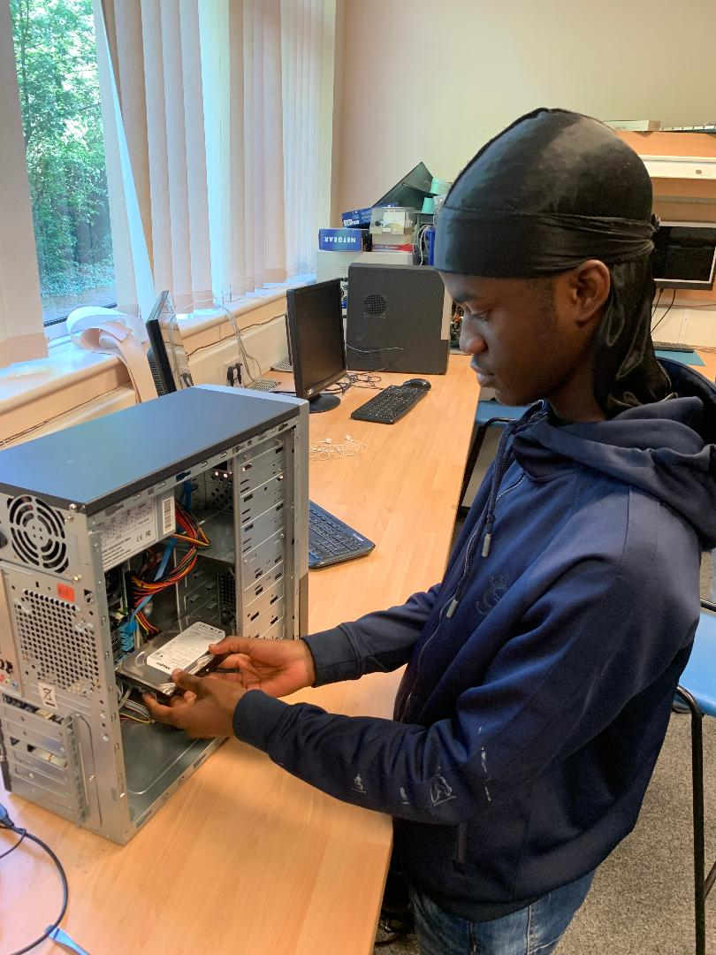
I then put in the hard drive and connected all the necessary wires into the hard drive, and put all the screws in.

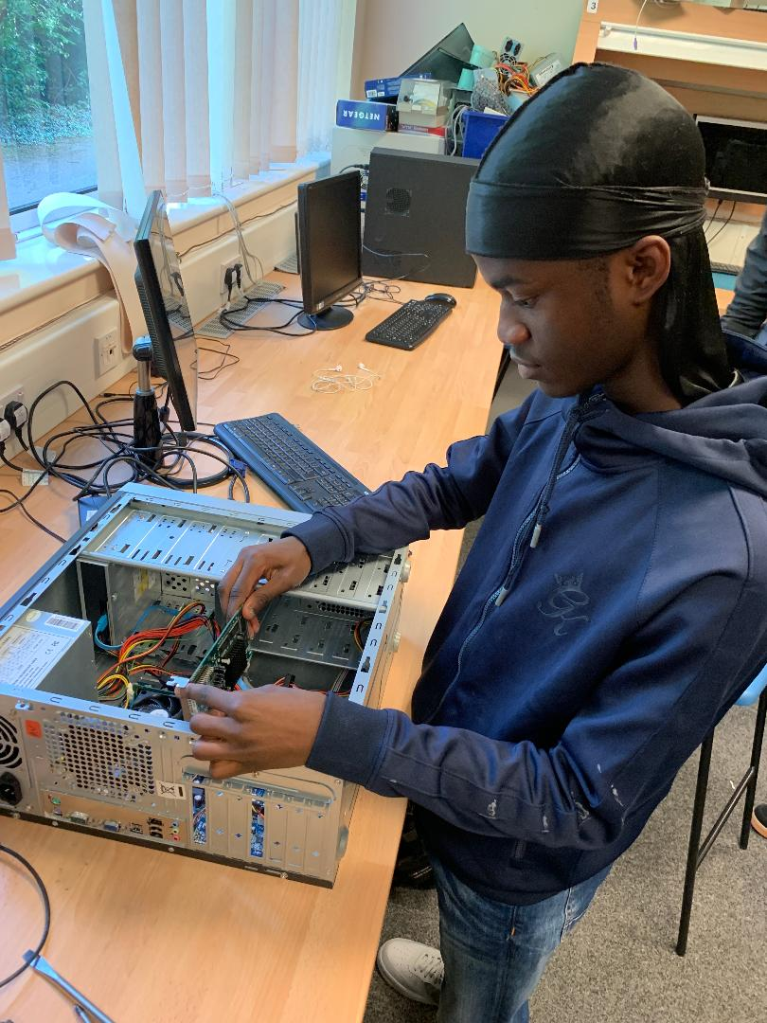
Lastly, I put the graphics card in making sure that the graphics card was in the correct war round otherwise it would not work.

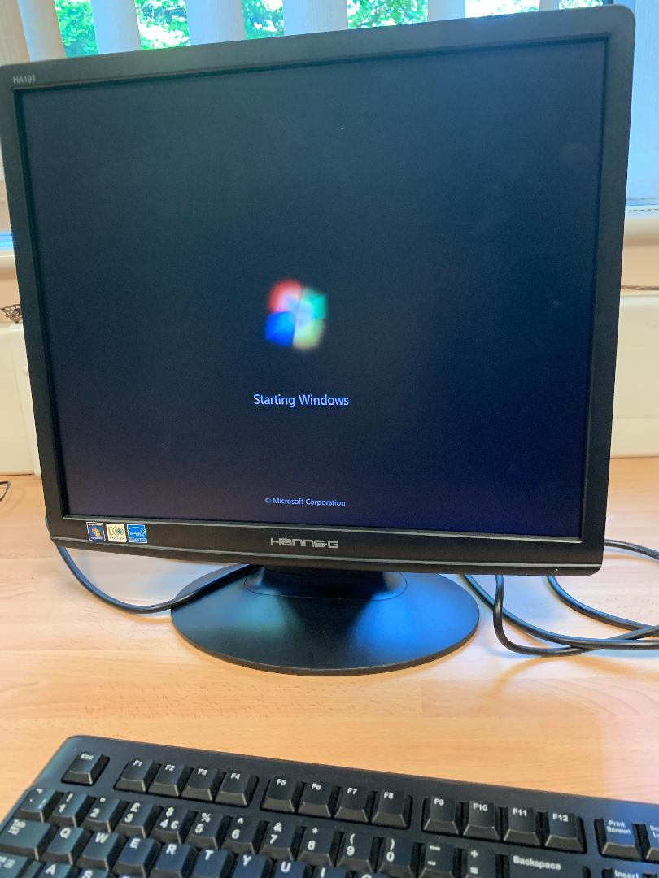
I then booted up the computer to see if my upgrades were effective.

Functionality
Here is where I had to go onto the system and check if the upgrade I made to the hard drive was successful or not. I also had to check if the upgrade to the graphic card was successful. I used device manager to check over the system. I used device manager because it would give me insight on the whole system and if there are any faults which means I would have to open the machine again and correct my mistake.

This is where I check if the upgrade I have made to the hard drive was successful. I did this by going on to device manager and checking on hard drive bit.

This is where I check if the upgrade I have made to the graphics card was successful. I did this by going on to device manager and checking on hard drive bit.

Test Table
Functionality | Method? | Result | Corrective action
RAM | I am going to boot up the computer and see if the screen is blank or if the screen boots up. | The computer system is working successfully, the screen has booted up | Worked successfully
Hard drive | I am going to install I better and working hard drive and check if it is working in the system. | The hard drive is successfully installed and is working. | Worked successfully
Graphics card | I am going to install I better and working graphics card and check if it is working in the system. | The graphics card is successfully installed and is working. | Worked successfully
Printer

How is the modified technology system suitable for the intended purpose?
The computer that I have upgraded, fixing two internal hardware components with faults and upgrading two internal hardware components. Fixing the RAM to allow the user to navigate through the system using the monitor, multi-task using the programs such was Office 365, to give the user improved performance in software programs. To allow user to work for long periods of time without any implications. Installing a better working hard drive to give the user more memory for files. Graphic card to give the user better quality when using certain software.
The instillation and upgrades have significantly improved the performance. At the start, the computer wouldn’t boot up, the screen was blank. I installed RAM to fix the blank screen so they can use it. I installed a hard drive, so the user would have a lot of storage space to save their important files. I carried out the tasks successfully and now the user can use his system with ease.

Use appropriate tools and techniques to protect the data and system settings

