Contents
UNIT 6: ASSIGNMENT 2
TASK 1 – SCENARIO 2
INVESTIGATING APPLES GRAPHIC PRODUCT 2
INTRODUCTION 2
EXPLAIN THE PURPOSE OF THE PRODUCT 3
EXPLAIN THE MAIN FEATURES OF THE PRODUCT 3
REVIEW WHETHER THE GRAPHIC PRODUCT IS FIT FOR PURPOSE 4
STRENGTH AND WEAKNESS OF THE GRAPHIC PRODUCT 4
INVESTIGATING PEPSI’S GRAPHIC PRODUCT 5
INTRODUCTION 5
EXPLAIN THE PURPOSE OF THE PRODUCT 5
EXPLAIN THE MAIN FEATURES OF THE PRODUCT 5
REVIEW WHETHER THE GRAPHIC PRODUCT IS FIT FOR PURPOSE 6
STRENGTH AND WEAKNESS OF THE GRAPHIC PRODUCT 6
UN UNIT 6: ASSIGNMENT 7
TASK 2: SCENARIO 7
MY ADVERT 7
THE INTENDED PURPOSE OF MY GRAPHIC PRODUCT 7
thE TARGET AUDIENCE FOR MY GRAPHIC PRODUCT 8
LIST OF ASSETS TO BE USED 8

UNIT 6: ASSIGNMENT

TASK 1 – SCENARIO
You work for a company that makes magazine covers, leaflets, posters and logos. You have been asked to create two graphic products for their clients. You have been provided with some basic information about the clients’ requirements.
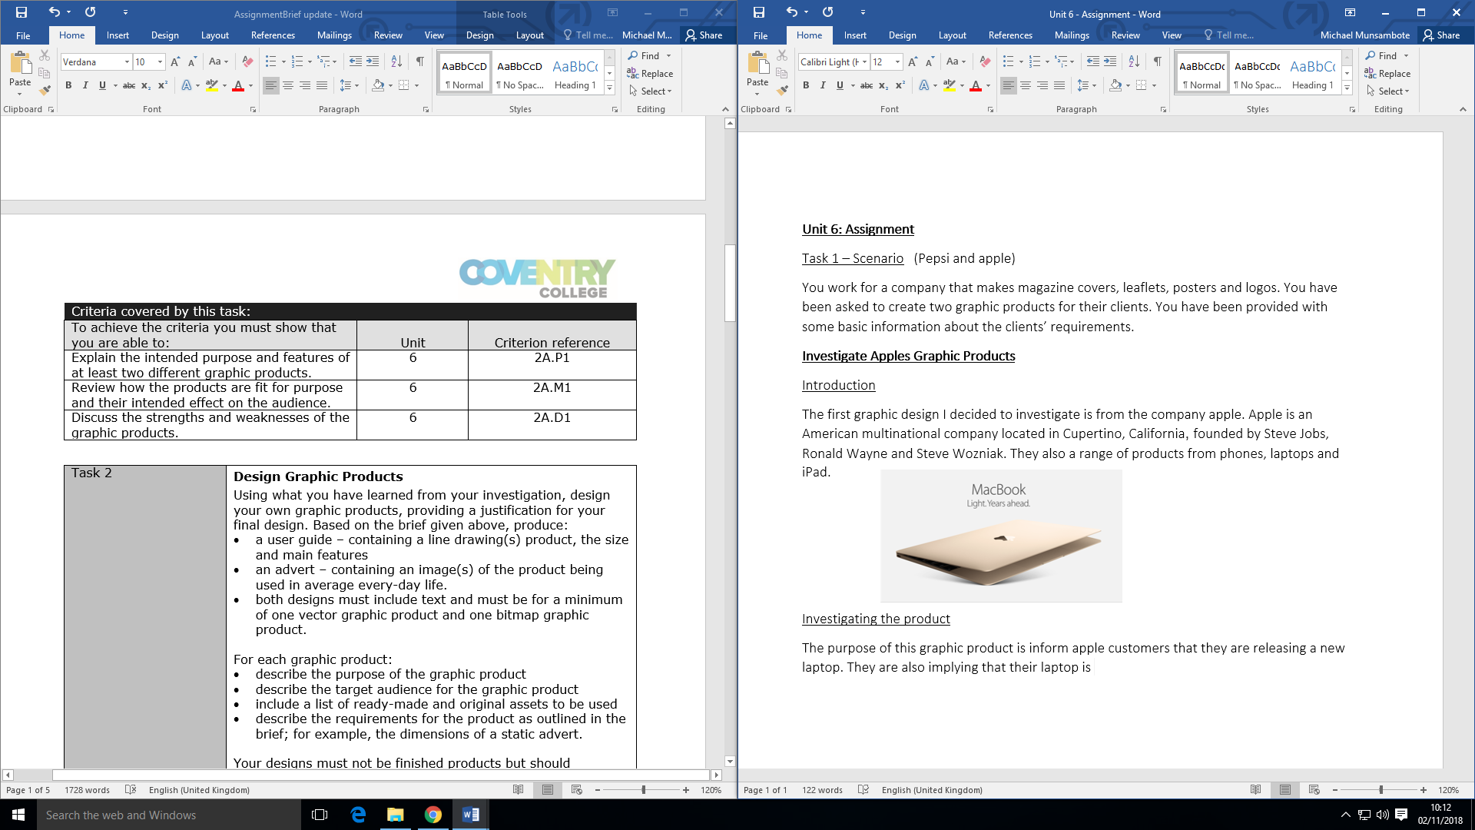

INVESTIGATING APPLES GRAPHIC PRODUCT

INTRODUCTION
The first graphic design I decided to investigate is from the company apple. Apple is an American multinational company located in Cupertino, California, founded by Steve Jobs, Ronald Wayne and Steve Wozniak. They also a range of products from phones, laptops and iPad.

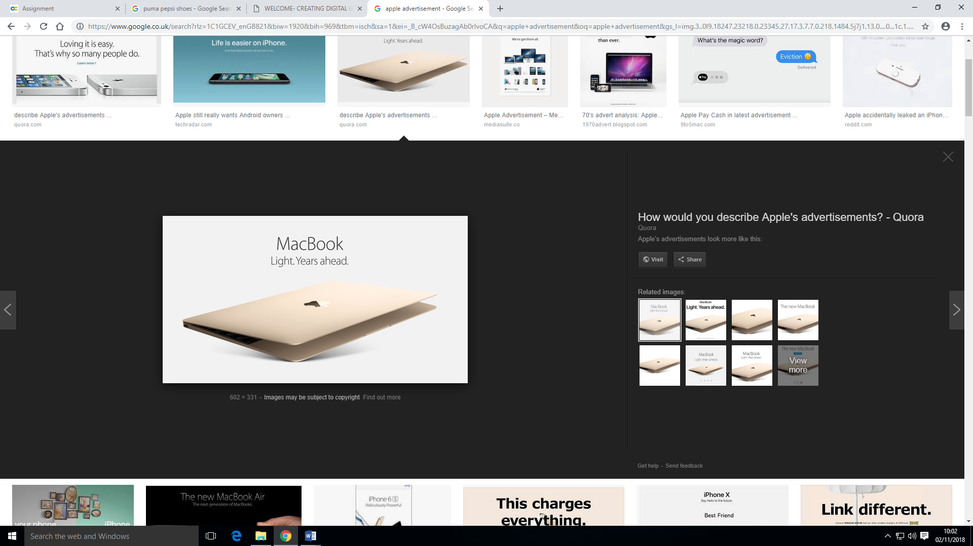

EXPLAIN THE PURPOSE OF THE PRODUCT
The purpose of this graphic product is inform Apple’s target audience that they are releasing a new laptop. The purpose of this advertisement is to attract their target audience’s attention and make them buy their laptop when it comes out. Another purpose of the product is to inform Apples audience that their new product is faster, lighter and better than any other competing product.

EXPLAIN THE MAIN FEATURES OF THE PRODUCT
A feature of this advertisement is a picture of their new product which lets their audience know what it looks like. They are also implying that their laptop is faster and better than other laptops produced by other companies. From looking at the text on the poster they have included the laptops name at the top middle part of the poster in large writing, this is so the audience done miss it, even if they don’t get a chance to see the picture they would at least have the chance to see the name of the laptop and they could do their own research. Also from analysing the text you can see that this laptop is going to be lighter as they have added a full top after the word light. ‘Light. In addition, you can see that the laptop is going to be different from other laptops ‘years ahead’ is implying that Apples laptop’s technology will be more advanced compared to other competitors. On this advertisement poster there isn’t a lot of colour except gold which is the colour of the laptop, white which is the colour of the background and black which is the colour of the text. The texture of the poster looks smooth as there is no hard corners everything has round corners, they don’t this so it matches with the laptop. The way they have positioned things on the poster. A bitmap displays colour of each pixel in the display space. The file format of bitmap images is JPEG. The apple advertisement is a bitmap because if you it has thousands of pixels mixed together to make the image.

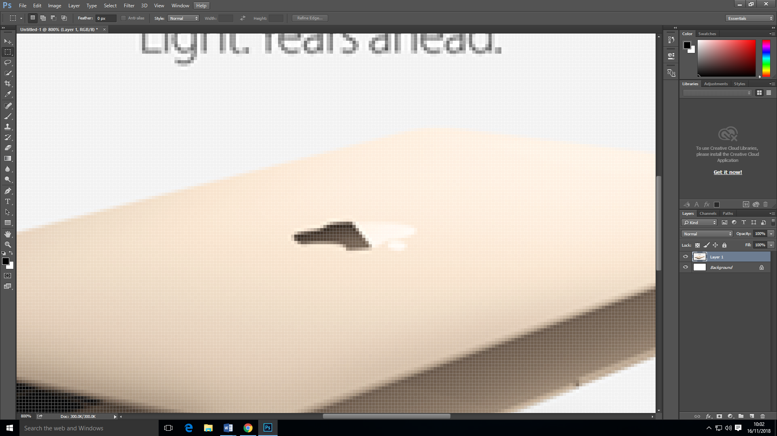

REVIEW WHETHER THE GRAPHIC PRODUCT IS FIT FOR PURPOSE
Looking at apples advert I can tell that their intended affect is to invoke emotion because when people see their advert they would want to know more about it, whether it has new features or if you can connect it to your phone and FaceTime. This advert also informs people that their laptops are better than other companies laptop’s. I think that this advert is aimed at adults and people who have jobs as Apples devices are quite expensive. The gender aimed at this advert is for everyone as they do not specify their products to a gender meaning anyone can go and buy any of their products. The age aimed at these products is towards 18+ as apple products can be quite expensive so young teenagers won’t be able to buy them. This product would make Apples audience interested because Apple is known for having a lot of features on their products so people would want to know what features the laptop has.
Strength | Weakness
You can see the whole product | Doesn’t give a release date
The advert is in high quality | Simple advertisement
 | You don’t get a lot of information about the product
 | Does not give a release date

STRENGTH AND WEAKNESS OF THE GRAPHIC PRODUCT

INVESTIGATING PEPSI’S GRAPHIC PRODUCT

INTRODUCTION
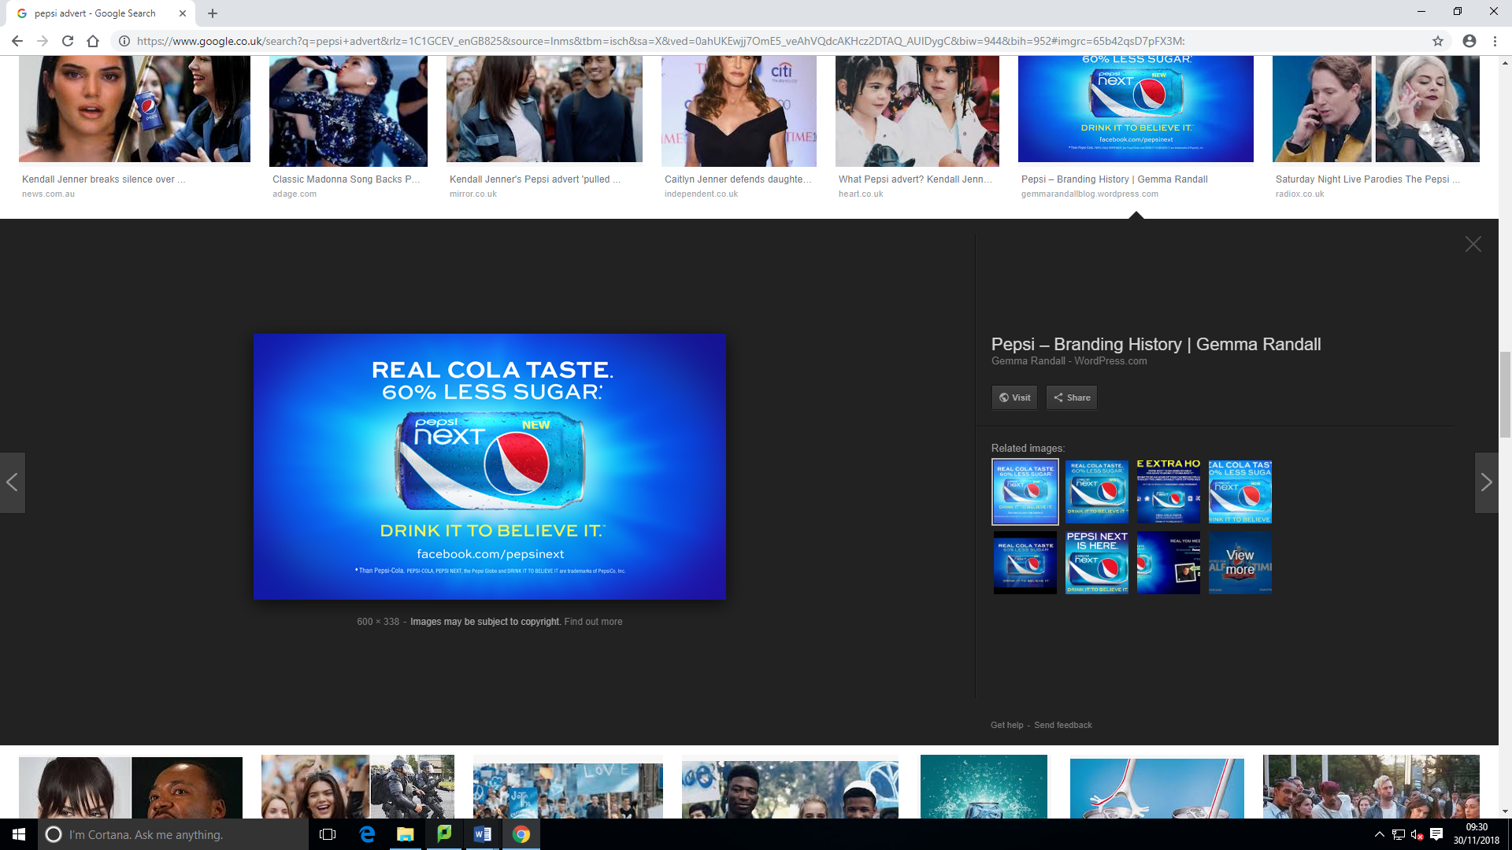
The second graphic product I have decided to investigate is Pepsi. Pepsi is a company based in the United States of America, founded by Caleb Bradham. Pepsi are also now starting to release clothing.

EXPLAIN THE PURPOSE OF THE PRODUCT
The purpose of this product is to inform their target audience that Pepsi is releasing a new product and it has 60% less sugar. Another purpose of the product is to make their target audience want the healthier Pepsi that still tastes like Pepsi.

EXPLAIN THE MAIN FEATURES OF THE PRODUCT
This advertisement has large text meaning a lot of people would be able to see their product, the text tells their target audience that the product is healthier because it has 60% less sugar but it still tastes of cola and this would make people want to drink it. This advertisement is really bright which would attract a lot of attention. The main colour in this advertisement is blue, they have taken the colour of the Pepsi bottle and made it the same as the background which makes it stand out and if people see the Pepsi bottle in shop they would know it is the new Pepsi. The size of the product on the advert is medium size and they have placed this in the centre of the advertisement so the target audience knows what product to buy. The way the advert is positioned shows the full product, the Pepsi can in positioned in the middle of the advertisement with the facts about it above and below the product. The characters used in the advert make it that the audience read all the information. The text on the advert is large and a different colour compared to the background which makes it easy to read and visible to all. A bitmap displays colour of each pixel in the display space. The file format of bitmap images is JPEG. The Pepsi advertisement is a bitmap because if you it has thousands of pixels mixed together to make the image.

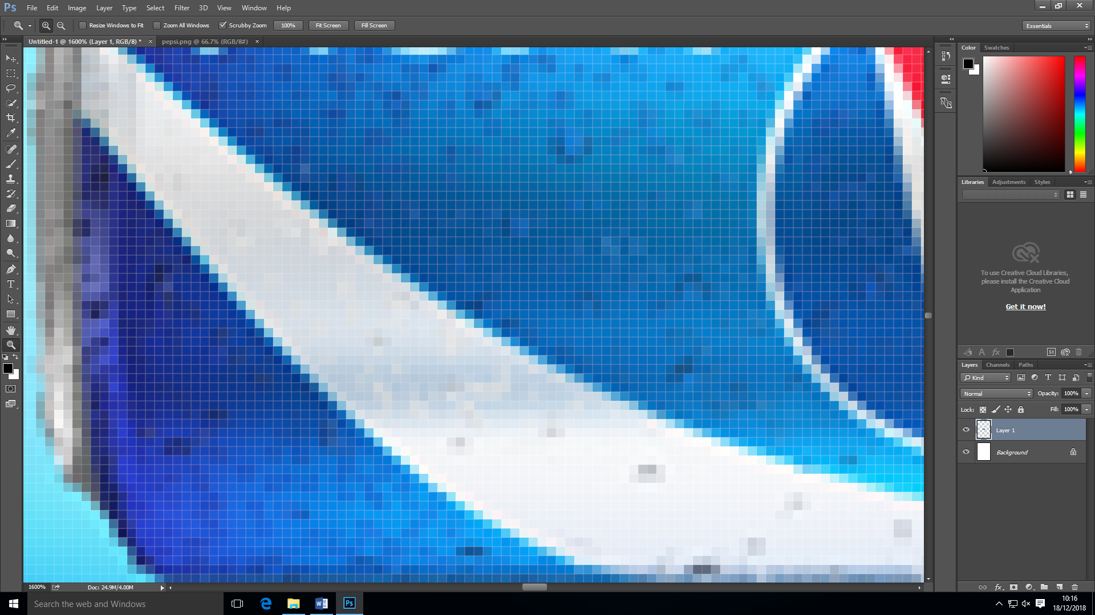

REVIEW WHETHER THE GRAPHIC PRODUCT IS FIT FOR PURPOSE
From looking at Pepsi’s advertisement I can tell that it invokes emotion because it would make their target audience at other people want to drink it because of the information that it has on the advertisement. This advertisement also informs people that they are changing the way they are making their drinks and this would make different audiences want to drink Pepsi. This advertisement informs different audiences because some people drink Pepsi because they find it too sugary but not they have reduced the sugar in their drink that audience would now want to drink Pepsi. Pepsi’s products are aimed at people of aged above the age of 12 because kids cannot drink, drinks with a lot of sugar. Pepsi products do not have a specific gender aim; their products are aimed at all genders.

STRENGTH AND WEAKNESS OF THE GRAPHIC PRODUCT
Strength | Weakness
You can see the whole product | People with colour-blindness will find it difficult to view the image
Vibrant colours (attracts attention)
It has good quality

